**SKILL LEARNT: REACT (WEEK 7)**

**EXERCISE 9: REACTJS-HOL**

STEP 1: First of all, I created the React app using the command “npx create-react-app cricketapp”.

STEP 2: After creating inside the src folder, I created 5 components - ListofPlayers.js, Scorebelow70.js, OddPlayers.js, EvenPlayers.js, ListofIndianPlayers.js.

STEP 3: The code for ListofPlayers.js is shown below

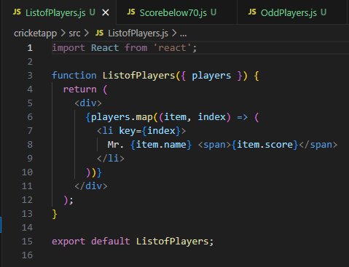

STEP 4: The code for Scorebelow70.js is shown below

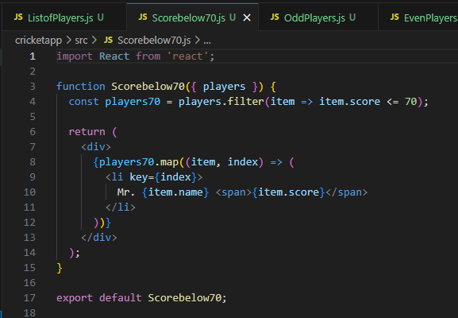

STEP 5: The code for OddPlayers.js is shown below

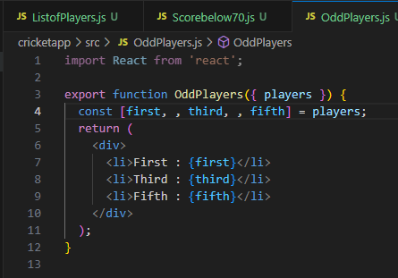

STEP 6: The code for EvenPlayers.js is shown below

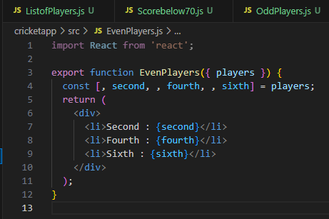

STEP 7: The code for ListofIndianPlayers.js is shown below

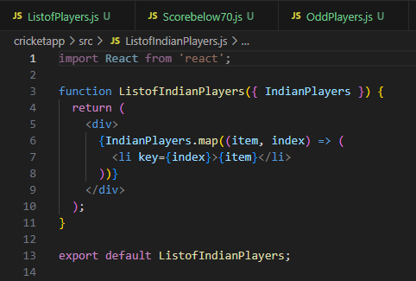

STEP 8: Since there are two set of output or results which will be displayed for the React application one when flag=true and one when flag=false. I have added a toggle view button to switch between the two states true and false so that I can view both the outputs as desired. The code for App.js is shown below

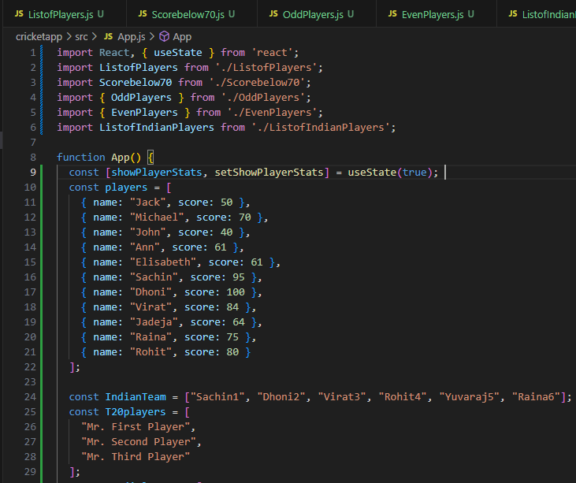

Continued…

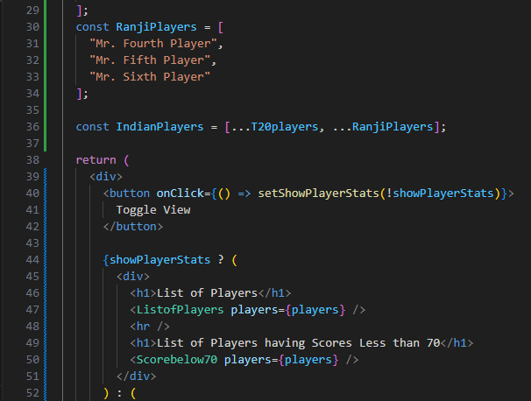

Continued…

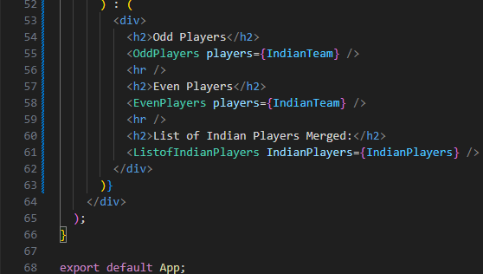

STEP 9: Once the code is written, we run the React Application by using the following command “npm start”.

STEP 10: The output is visible in “localhost:3000”. It is shown below

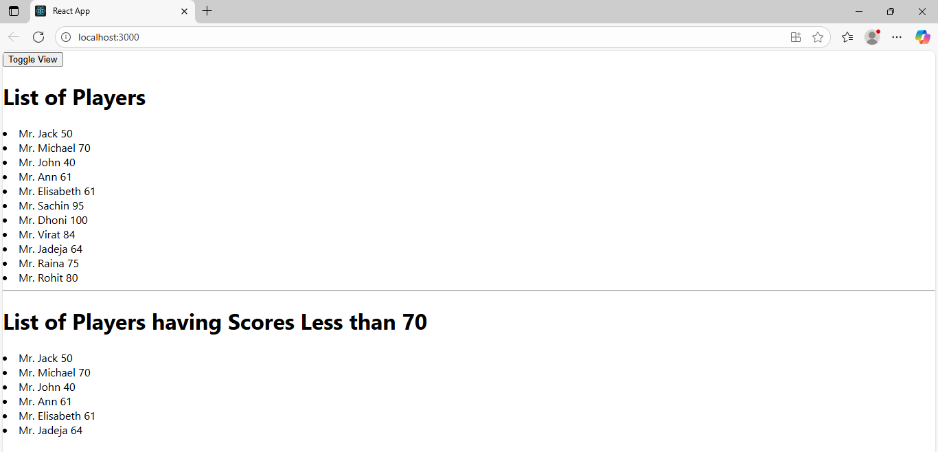

Continued….

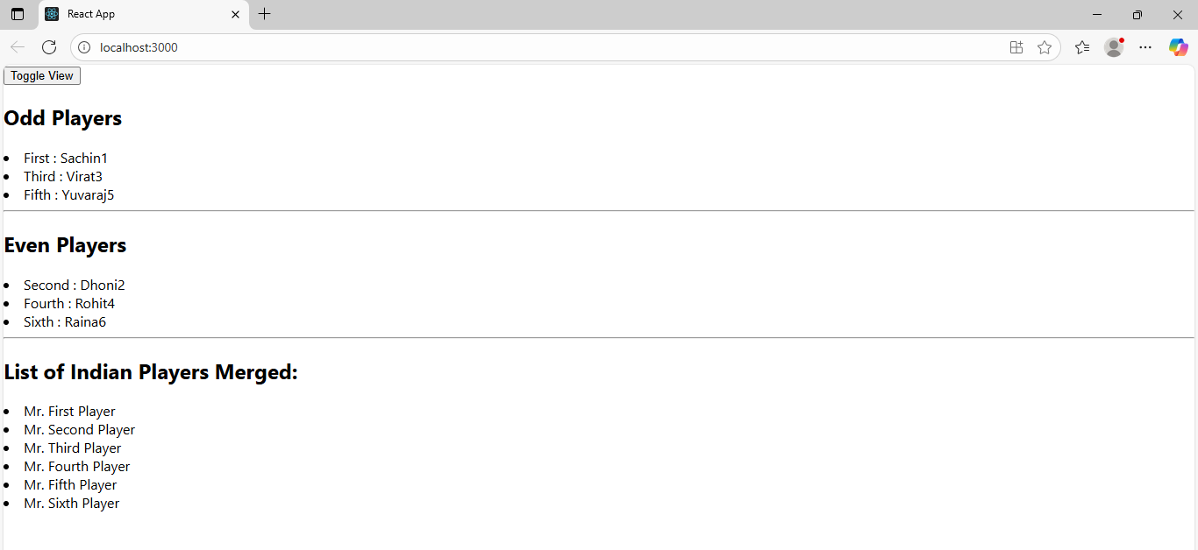

**EXERCISE 10: REACTJS-HOL**

STEP 1: First, I created the React application named officespacerentalapp using the command “npx create-react-app officespacerentalapp”.

STEP 2: After creating the project, under the src folder I edited and modified the App.js folder.

STEP 3: Since the project is on office space rental matter, I downloaded a random image of an office space and saved it the public folder of the React application.

STEP 4: Then I added the path of the image to the App.js component along with the other details. The code for App.js is shown below

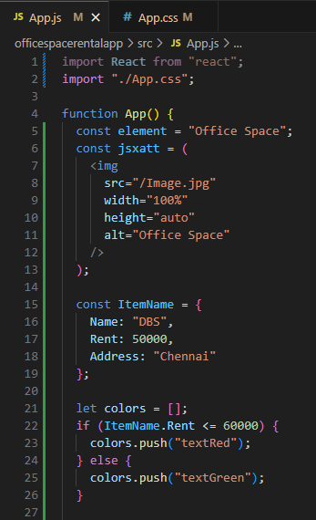

Continued….

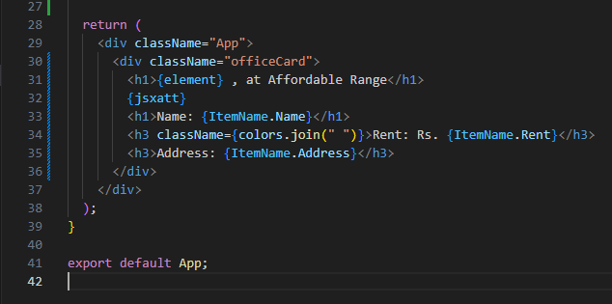

STEP 5: Then I edited the App.css component to add styling and the required fonts. The code for App.css is shown below

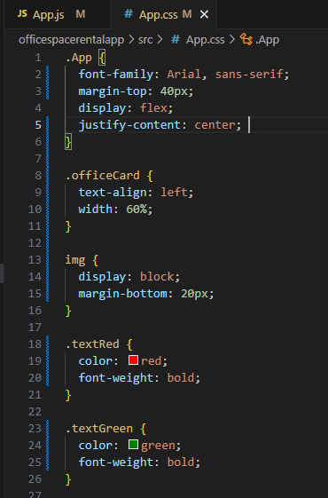

STEP 6: Once the code is written, we run the React Application by using the following command “npm start”.

STEP 7: The output is visible in “localhost:3000”. It is shown below

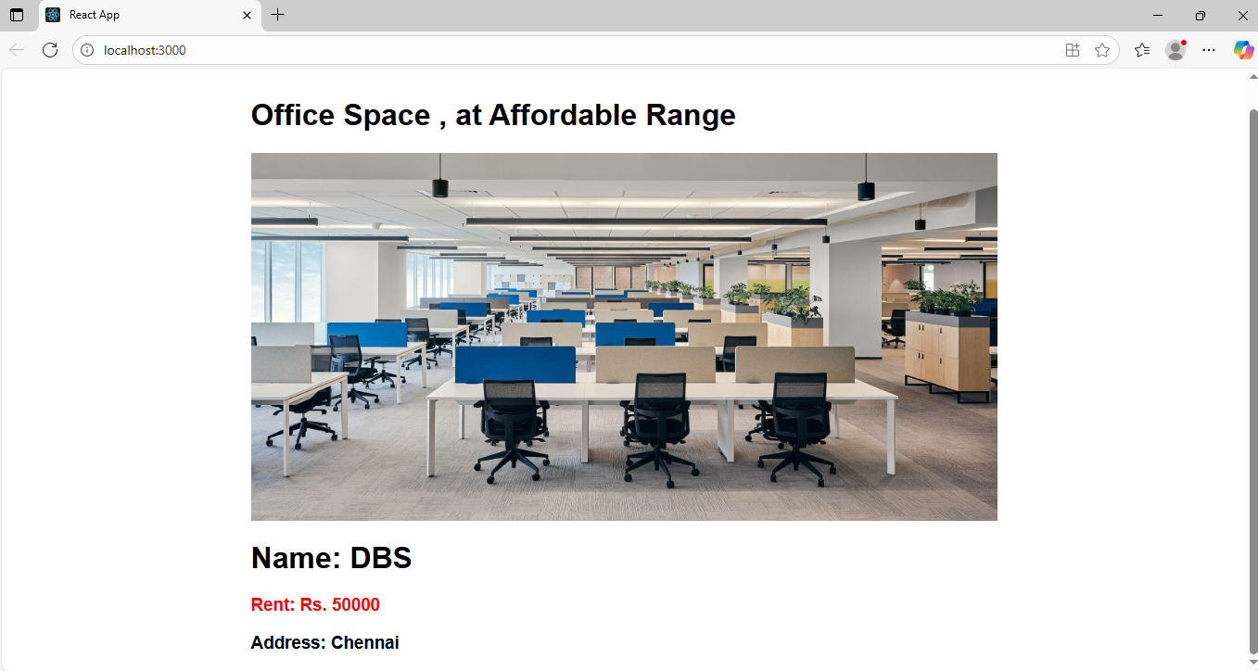

**EXERCISE 11: REACTJS-HOL**

STEP 1: First I created the React project named eventexamplesapp using the command npx create-react-app eventexamplesapp.

STEP 2: I modified the App.js component to add all the functionalities into it. The code for it is given below

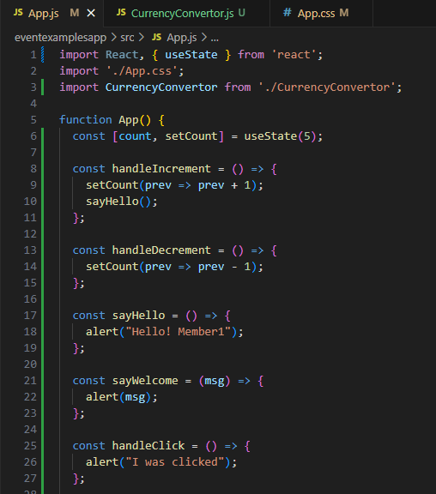

Continued….

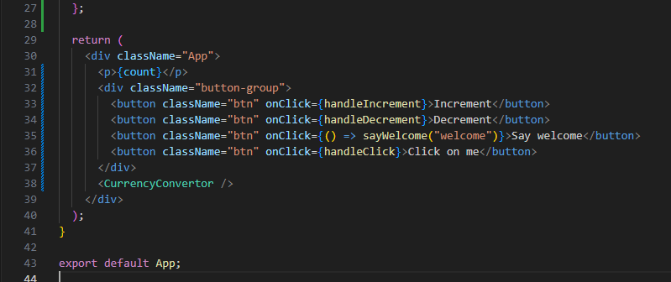

STEP 3: I also edited the App.css component to add styling and fonts. The code for it is shown below

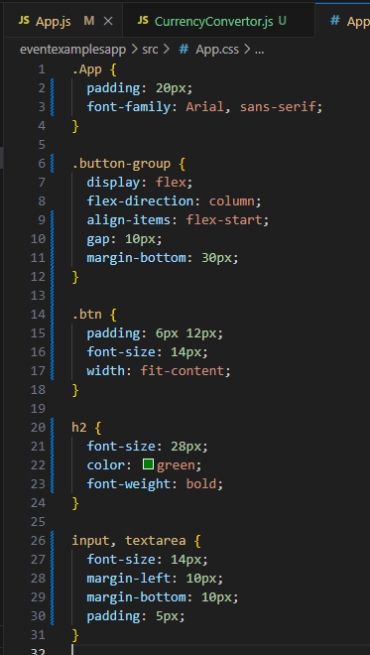

STEP 4: Under the src folder, I also created another component named CurrencyConvertor.js. The code for it is shown below

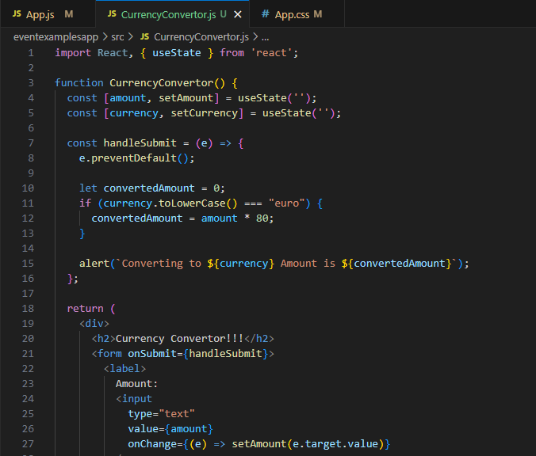

Continued….

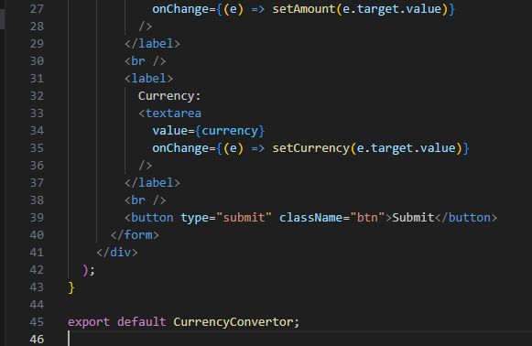

STEP 5: Once the code is written, we run the React Application by using the following command “npm start”.

STEP 6: The output is visible in “localhost:3000”. It is shown below

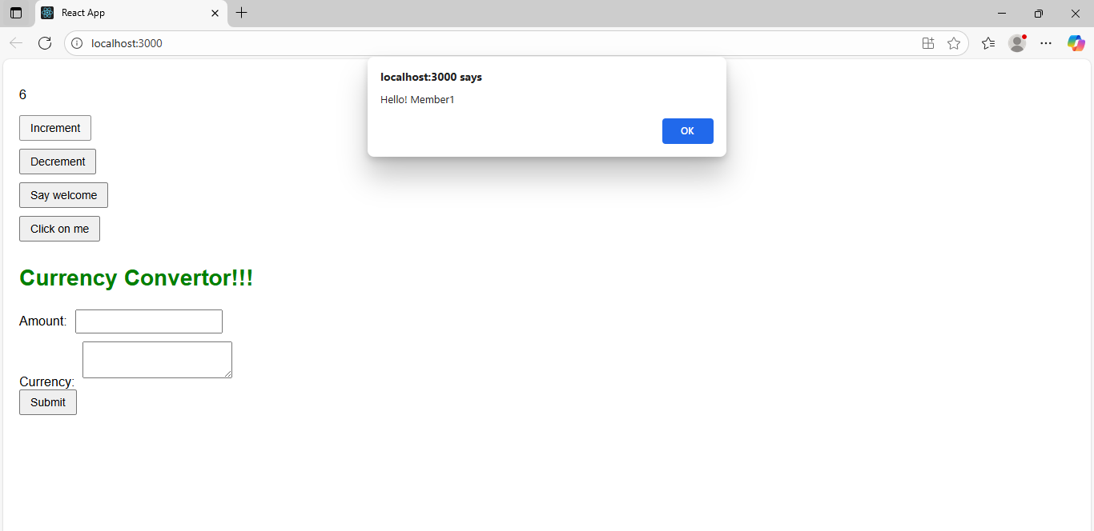

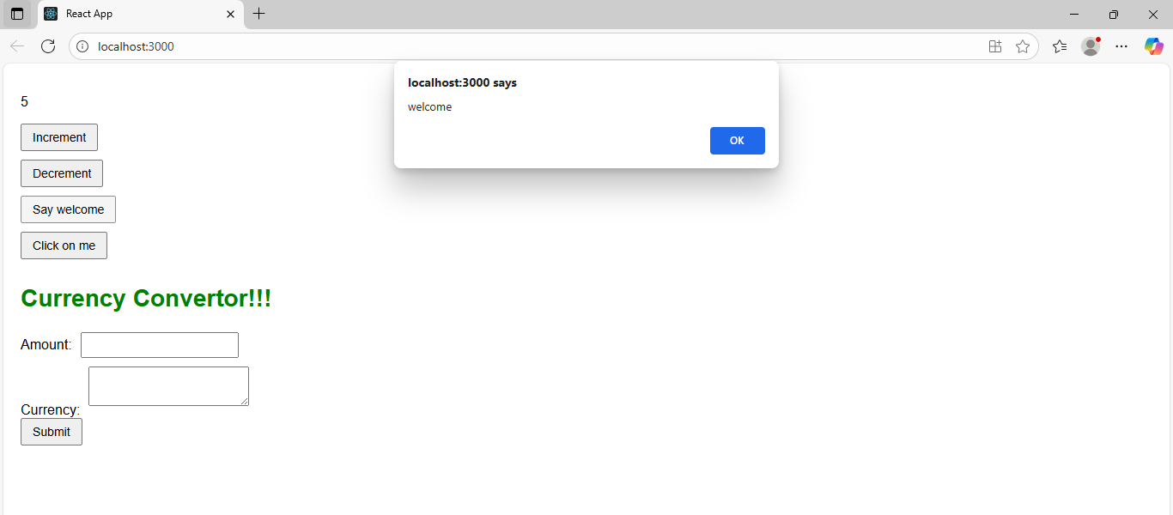

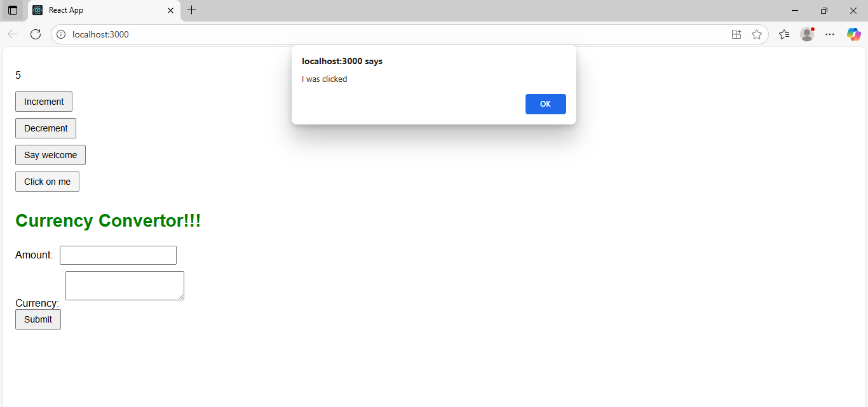

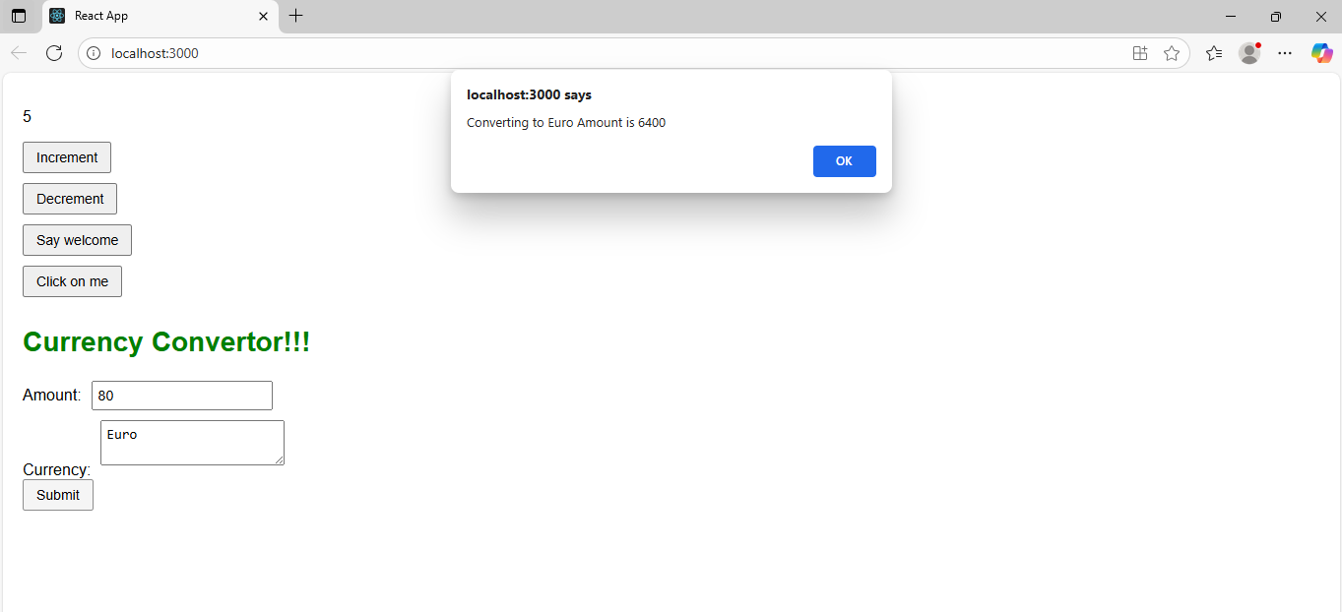

**EXERCISE 12: REACTJS-HOL**

STEP 1: First I created the React application named ticketbookingapp using the command “npx create-react-app ticketbookingapp”.

STEP 2: Next under the src folder I added two components named LoginButton.js and LogoutButton.js for the button functionality.

STEP 3: The code for LoginButton.js is shown below

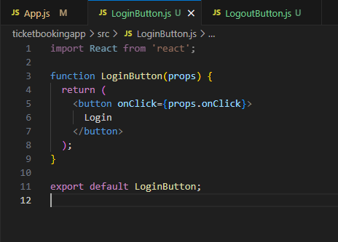

STEP 4: The code for LogoutButton.js is shown below

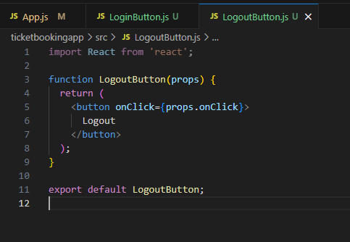

STEP 5: The code for App.js is also edited and modified.

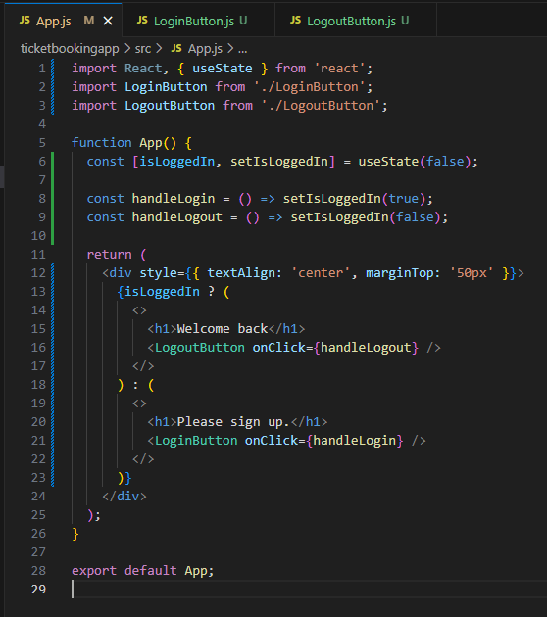

STEP 6: Once the code is written, we run the React Application by using the following command “npm start”.

STEP 7: The output is visible in “localhost:3000”. It is shown below

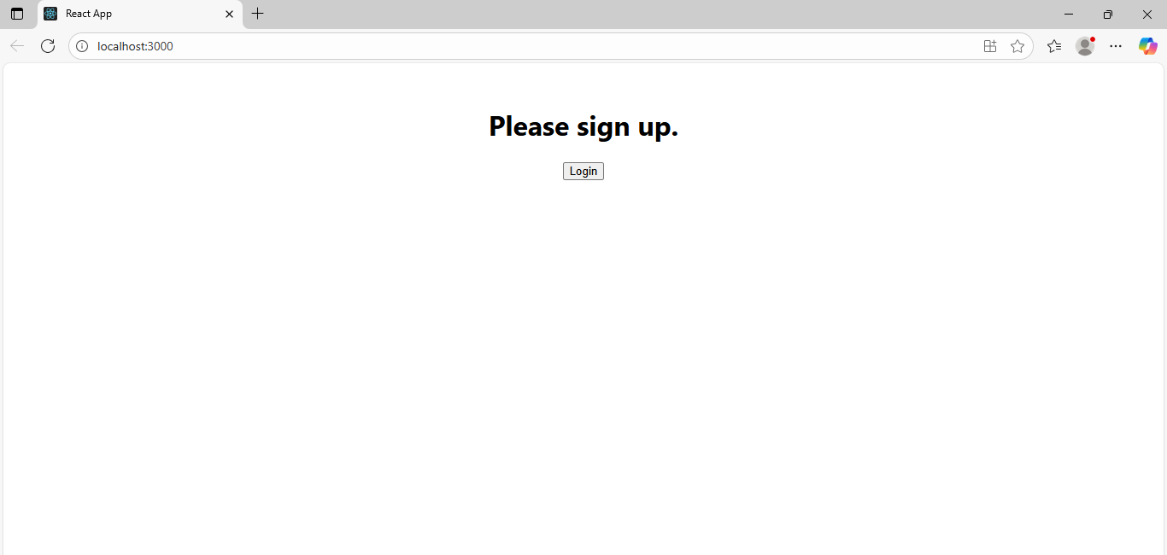

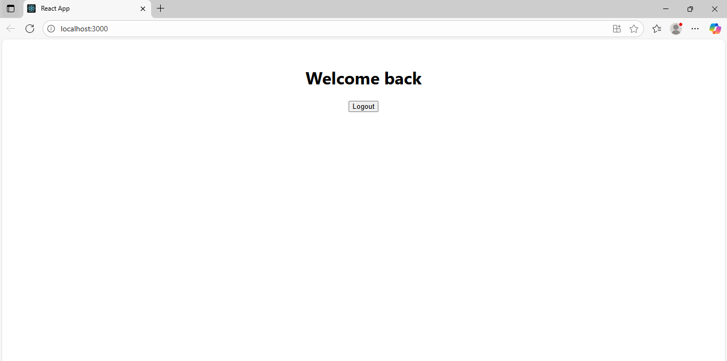

**EXERCISE 13: REACTJS-HOL**

STEP 1: First, I created the React application named bloggerapp using the command “npx create-react-app bloggerapp”.

STEP 2: After creating I added 4 components inside the src folder BookDetails.js, CourseDetails.js, BlogDetails.js and data.js.

STEP 3: The code for BookDetails.js is shown below

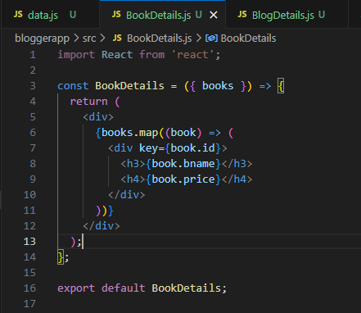

STEP 4: The code for CourseDetails,js is shown below

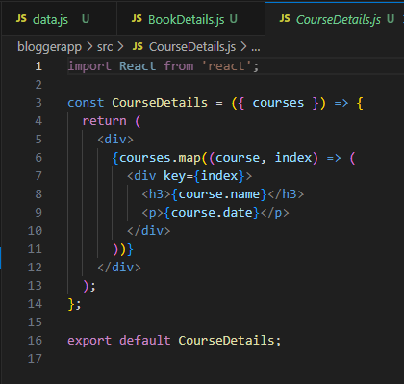

STEP 5: The code for BlogDetails.js is shown below

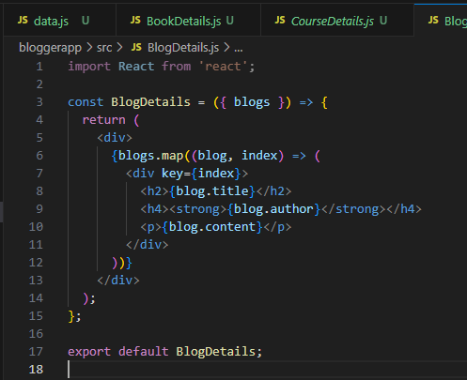

STEP 6: The code for data.js is shown below

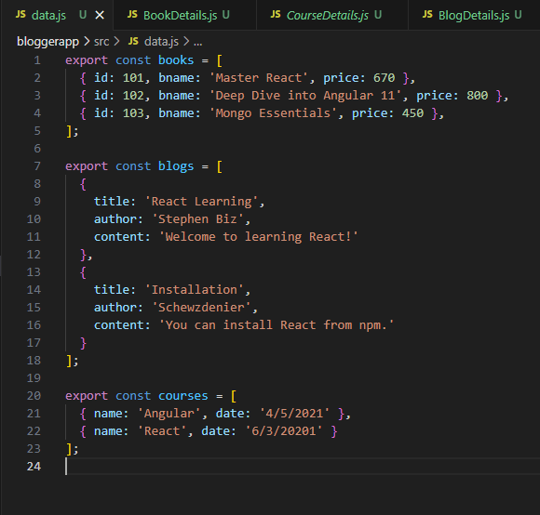

STEP 7: I modified the App.js to add the components.

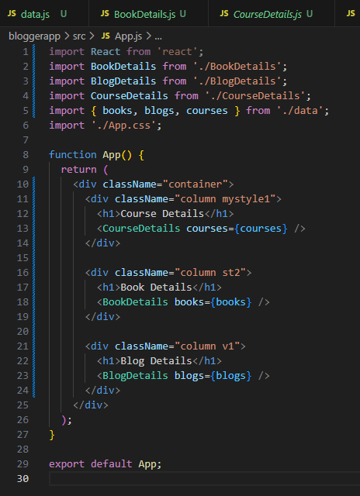

STEP 8: I also modified the App.css folder to add the stylings and font.

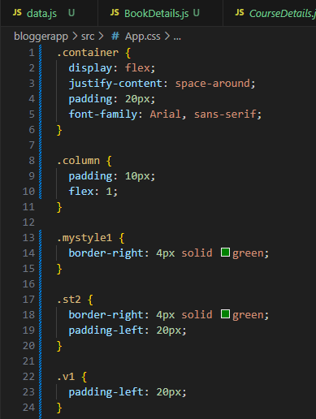

STEP 9: Once the code is written, we run the React Application by using the following command “npm start”.

STEP 7: The output is visible in “localhost:3000”. It is shown below

